Call for Session Proposals

We invite you to submit a proposal for a concurrent session at the 2015 Consumer Voice Annual Conference. Sessions that include more than one perspective or speakers from more than one program are encouraged.

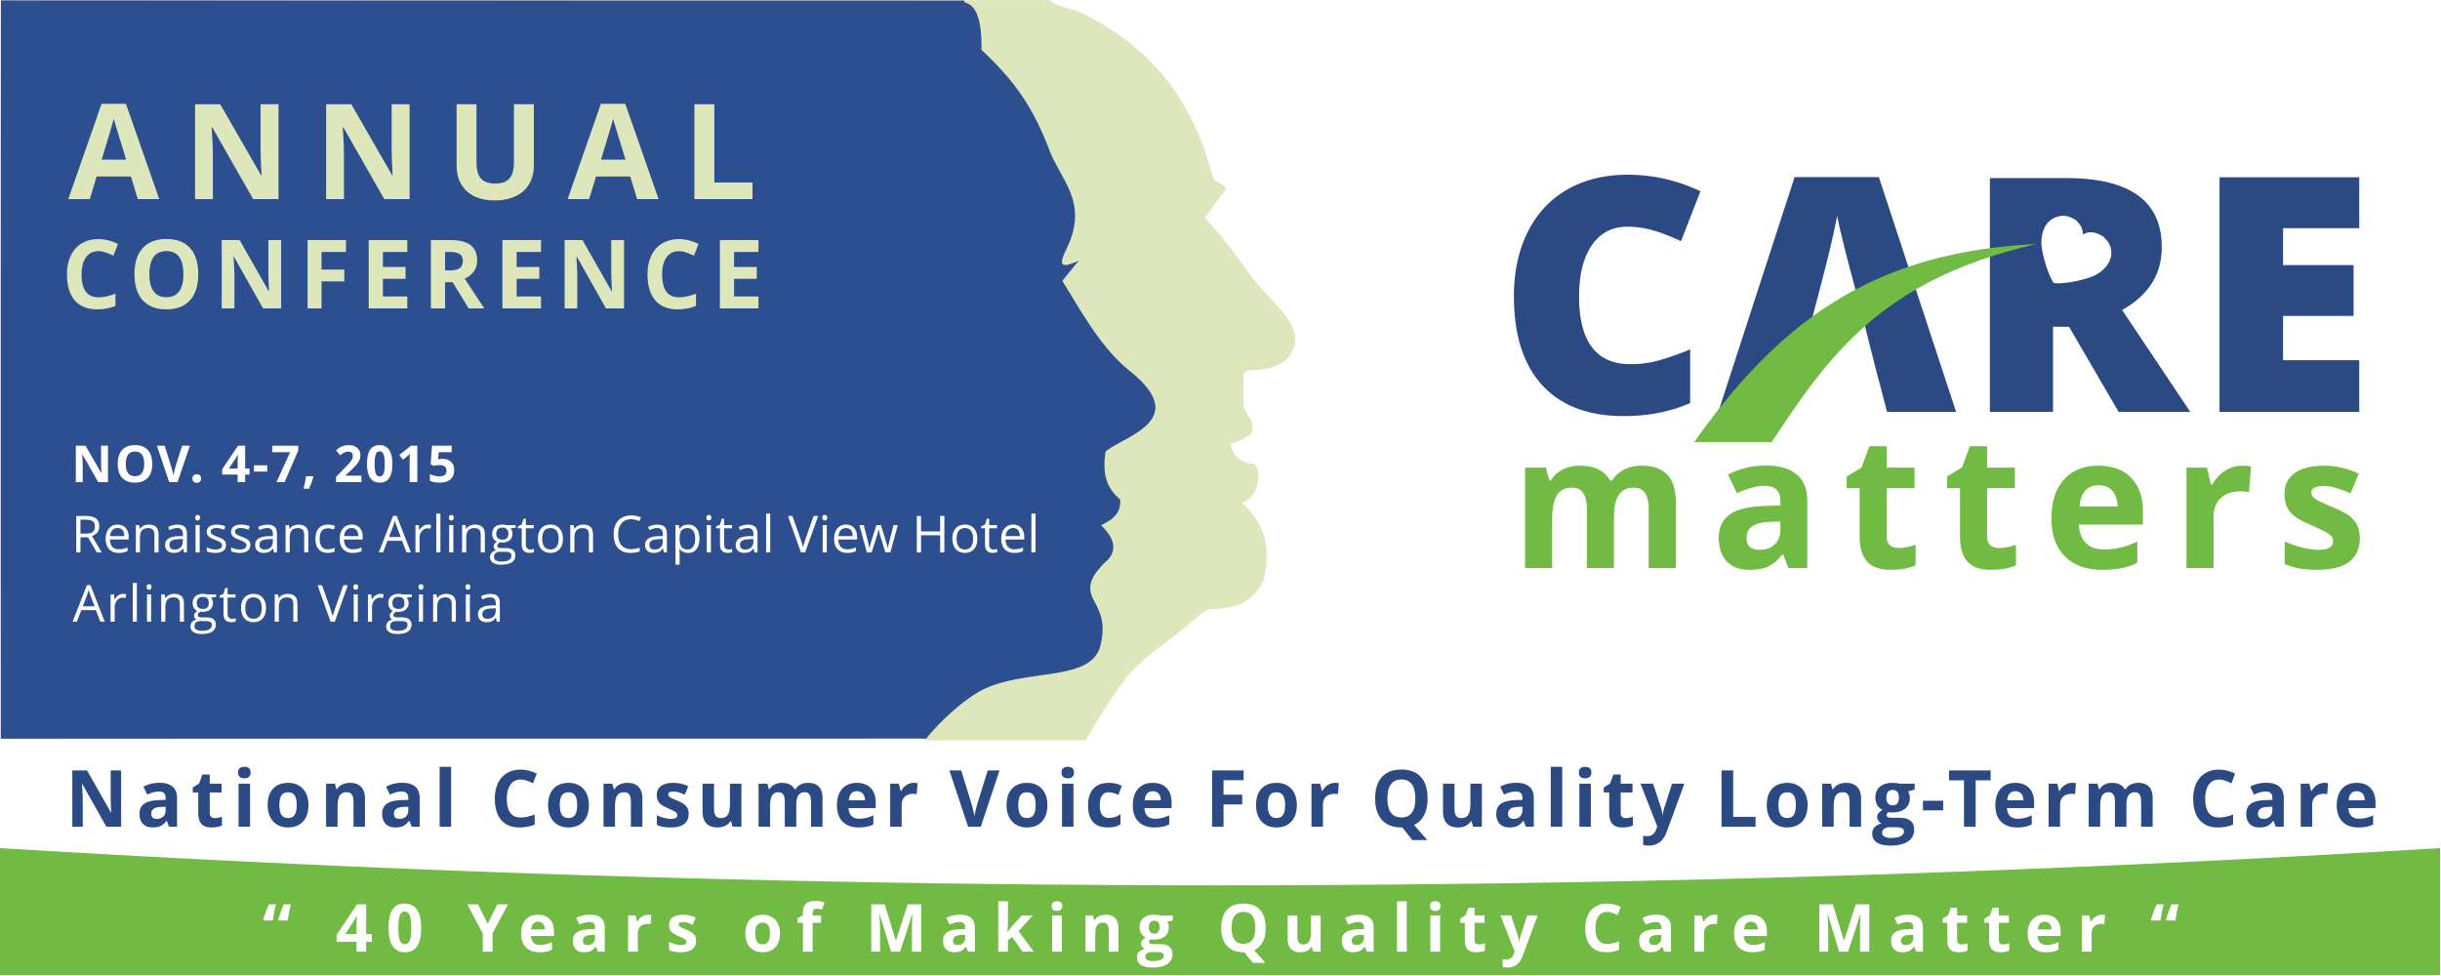

Proposal Guidelines:
- The Conference will be November 4-7, 2015 at the Renaissance Arlington Capital View Hotel in Arlington, VA. The bulk of workshops will be November 5-7.
- All proposals must include speaker names, contact info, and a short bio of credentials
- All speakers must register and pay the applicable conference rate by August 1, 2015.
- Travel expenses cannot be reimbursed.
- Speakers must provide electronic versions of any PowerPoint’s, reference materials, or handouts by October 15, 2015.
- Speakers are responsible for bringing handouts if any will be used. PowerPoint capability will be available in all workshop rooms (screen, projector, computer). If you require additional AV support, there may be an additional charge.
- Proposals may be submitted for more than one session, but you must submit a separate form for each proposal
- Sessions will be either 75 minutes or 90 minutes in length

All proposals must be received by June 26, 2015 to be considered.

Submit proposals as Word or PDF documents to the Consumer Voice at info@theconsumervoice.org.

CONFERENCE SESSION PROPOSAL

DUE BY JUNE 26, 2015

This proposal is in the following category (Select only 1)

Providing Quality Care
Residents’ Rights/Quality of Life
Guardianship
Staffing
Elder Abuse, Neglect, Exploitation
Assisted Living
Nursing Home Standards
Medicaid Managed LTSS
HCBS Regulations
Ombudsman Skills Training
Ombudsman Program Management
Advanced Care Planning
Quality Measures

Program Title: (10-word maximum):

Brief description for the Conference program (75-word maximum):

Learning Objectives (3):
1.
2.
3.

Full session description, include: (1) issues to be addressed, (2) how/why the content is applicable to other programs or states (3) presentation style (lecture, small group, interactive)

Target Audience: (Basic, Experienced, Advanced)

Preferred amount of time, check one: 75 minutes ______ 90 minutes_______

SPEAKER INFORMATION

Lead Presenter

Name:

Title:

Organization:

Address:

Phone:

Email:

Short Bio:

Additional Speakers

Name:

Title:

Organization:

Address:

Phone:

Email:

Short Bio:

Name:

Title:

Organization:

Address:

Phone:

Email:

Short Bio:

******************************

By submitting this proposal you agree to:
- Register and pay the applicable fee by August 1, 2015 (or within 30 days of being notified that your proposal has been accepted for inclusion on the agenda, whichever is later)
- Submit in electronic form any PowerPoint, materials, or handouts for the session no later than October 15, 2015.
- Attend the conference and present the session as described in the proposal.

PROPOSALS ARE DUE JUNE 26, 2015
TO THE CONSUMER VOICE
info@theconsumervoice.org.

